R-H. Hadron Physics
Wigner Research Group
Róbert Vértesi, Gyula Bencédi, Zoltán Fodor^{A}, Endre Futó^{A}, Sándor Hegyi, Gábor Jancsó^{A}, József Kecskeméti^{A}, Gabriella Pálla^{E}, Zoltán Seres^{A}, Ferenc Siklér, Mónika Varga-Kőfaragó.
Contributing students: László Gyulai, Eszter Frajna, Anett Misák, Attila Rádl, Ákos Sudár, Olivér Surányi, Balázs Endre Szigeti, Zoltán Varga.
Our research group aims to gain a better understanding of the strong interaction, one of Nature’s fundamental forces, under extreme conditions. We participate in several complementary experiments (mainly ALICE and CMS), where we play leading roles in heavy-flavor and correlation measurements in high-energy nuclear reactions as well as in the exploration of gluon states in proton-proton collisions. We continue to play an active role in phenomenological and methodological studies such as the analysis of collective phenomena in small colliding systems and the development of novel particle tracking and identification algorithms. We apply our expertise in the field of detectors in developing a new proton-CT method for medical diagnosis and treatment.
Angular-correlation measurements. — We have analyzed the Pb-Pb and p-Pb data taken by the ALICE collaboration in 2015 and 2018. New results from this analysis showed a similar broadening of the jet peak towards central collisions at low transverse momentum in Pb-Pb collisions at √s_{NN} = 5.02 TeV as what was seen previously at √s_{NN} = 2.76 TeV. [1] In addition, identified two-particle angular correlations in Pb-Pb collisions at √s_{NN} = 5.02 TeV showed that both the broadening of the jet peak and the depletion yield depend on particle species dependence. Different Monte Carlo event generators (PYTHIA8/Angantyr, AMPT, JetScape) were used to determine the origin of the observed phenomena (Fig. 1 left). The trends observed for both identified and unidentified particles are reproduced by AMPT, hinting that microscopic processes alone are not sufficient to understand the observed jet broadening [2].
Heavy-flavour jets and correlations. — Since heavy (charm and bottom) quarks are mostly created in the initial hard scatterings and their numbers are largely unchanged throughout the reaction, they serve as ideal probes to test the properties of the strongly interacting medium produced in such collisions. Jets containing heavy flavour hadrons probe the influence of mass and color-charge effects on fragmentation, as well as provide insight to gluon-splitting processes. The ALICE detector has the unique capability of measuring beauty-jets down to relatively low momenta. Our group plays a leading role in ALICE heavy-flavour jet and correlation measurements. Preliminary results of beauty-jet cross sections and nuclear modification factors in p-Pb collisions at √s_{NN} = 5.02 TeV (Fig. 2 left) indicate that the nuclear modification of beauty jets by cold nuclear matter effects are weak [3]. We also analyzed azimuthal-correlation distributions of D mesons and light hadrons (D-h) in pp collisions at √s = 5.02 TeV in simulations with the PYTHIA 8 event generator. The results provide a better understanding on the role of partonic and hadronic effects in the developing correlation patterns, thus help us interpret charm production, understand their fragmentation, hadronization, and may also aid the identification of heavy particles [4]. In addition, we are working on ALICE analyses and simulations aimed at the understanding of the multiplicity-dependence of D-h correlations and their relations to the underlying event (Fig. 1 right).
Study of small collision systems with identifed particles. — The transverse-momentum spectra of light-flavour hadrons in pp collisions measured over a broad p_{T} range provide important input for the study of particle production mechanisms in the soft and hard scattering regime of QCD. We play a leading role within ALICE in the measurement and publication of light-flavour identified hadron spectra measured at mid-rapidity in inelastic pp collisions at 13 TeV. These measurements complement the existing ones at lower collision energies, allowing particle production to be studied over a wide range of √s. Furthermore, we investigated the multiplicity and spherocity dependencies of the average transverse momenta and integrated yields as a function of charged-particle multiplicity [5]. Recently we started to investigate the multiple-parton interactions with identified particles in pp collisions by studying the underlying event as a function of multiplicity. Also, by going to extremely high multiplicities with a designated trigger in the LHC Run-2 data taking period we aim to understand the strangeness enhancement observed in small systems, and consequently get better insight into collective-like phenomena.
Physics with pomerons. — Within the CMS Collaboration, we have started a comprehensive study of double pomeron exchange, central exclusive production of charged hadron pairs in pp collisions at a center-of-mass energy of 13 TeV. Events are selected by requiring both scattered protons detected in the roman pots, exactly two oppositely charged identified particles in the silicon tracker, and the momentum balance of these four particles. The interplay of resonant and nonresonant continuum processes is studied through multi-dimensional measurements using scattering angles and squared four-momentum transfers of the incoming protons, together with the invariant mass and decay angles of the centrally produced system. A rich structure of interactions related to double pomeron exchange emerges. The dynamics of various f₀ and f₂ resonances and the nonresonant continuum is used to test models on spin content, vector or tensor nature, of the pomeron.
Jet structures. — The discovery of collective-like behavior in high-multiplicity pp and p-A collisions was a major surprise in early LHC results. While the presence of the Quark-Gluon Plasma is needed to explain such collective behavior is still an open question, relatively soft vacuum-QCD effects such as multiple-parton interactions or the rearrangement of the color structure may also provide a viable explanation. Although the properties of jets are well described by different Monte Carlo event generators, discrepancies have been found in various corners of the phase space. Using the PYTHIA8 and HIJING++ Monte-Carlo event generators, we gave predictions for multiplicity-dependent jet structures. We demonstrated that vacuum QCD effects can modify the jet structure as well as two-particle angular correlation patterns in high-multiplicity events [6]. In Fig. 2 (right) we show predictions for the flavour-dependence of jet shape modification at various multiplicities [7]. Besides that, we investigated the effect of quark fragmentation on the final state of high energy proton-proton collisions using jet substructure observables. We have used several Monte Carlo event generators with different color reconnection algorithms, and compared the predictions with CMS data. According to the ongoing analysis results, the charge distribution of jets with rapidity gap is sensitive to the applied color reconnection algorithm.
Novel reconstruction methods. — We have published a paper on a novel combination of data analysis techniques for the reconstruction of all tracks of primary charged particles, as well as of daughters of displaced vertices, created in high energy collisions. [8] Instead of performing a classical trajectory building or an image transformation, an efficient use of both local and global information is undertaken while keeping competing choices open. The measured hits of adjacent tracking layers are clustered first with the help of a mutual nearest neighbor search in the angular distance. The resulted chains of connected hits are used as initial clusters and as input for cluster analysis algorithms, such as the robust k-medians clustering. The clustering is complemented with elements from a more sophisticated Metropolis-Hastings MCMC algorithm, with the possibility of adding new track hypotheses or removing unnecessary ones. Simplified but realistic models of today's silicon trackers are employed to test and study the performance of the proposed method as a function of the particle multiplicity in the collision event (Fig. 3).
Medical applications of high energy detector technologies. — We participate in the development of a sampling calorimeter to be used for imaging in cancer therapy [9-10]. Irradiation of cancer tumors using well-focused hadron (most commonly proton) beams can be a very effective treatment as the patient receives less unnecessary dose, thus allowing for a deposit of high destructive dose close to the critical organs. The ALPIDE calorimeter is based on the silicon pixel detector developed for the upgrade of the Inner Tracking System of ALICE. We have analyzed the data of a test beam measurement (Fig. 4 left). We determined the energy dependence of the cluster size of this pixel detector between 50 and 220 MeV/μ for alpha and proton particles (Fig. 4 right) [11]. We also measured the efficiency of the tracking algorithm on previous energy, which was higher than 99% in case of alpha particles. Furthermore, we participate in the mechanical design of the calorimeter. We have calculated the temperature distribution inside the calorimeter to find the optimal cooling system concept for the detector.
References
- DOI: 10.1016/j.nuclphysa.2018.09.055.
- DOI: 10.3390/universe5050097.
- DOI: 10.3390/universe5050130
- DOI: 10.3390/universe5050118.
- DOI: 10.1016/j.nuclphysa.2018.08.021.
- DOI: 10.1155/2019/6731362.
- DOI: 10.3390/universe5050132.
- DOI: 10.3390/universe5050105.
- DOI: 10.3390/universe5050128.
- DOI: 10.1016/j.ejmp.2019.05.026.
- DOI:10.1016/j.nima.2019.162626.

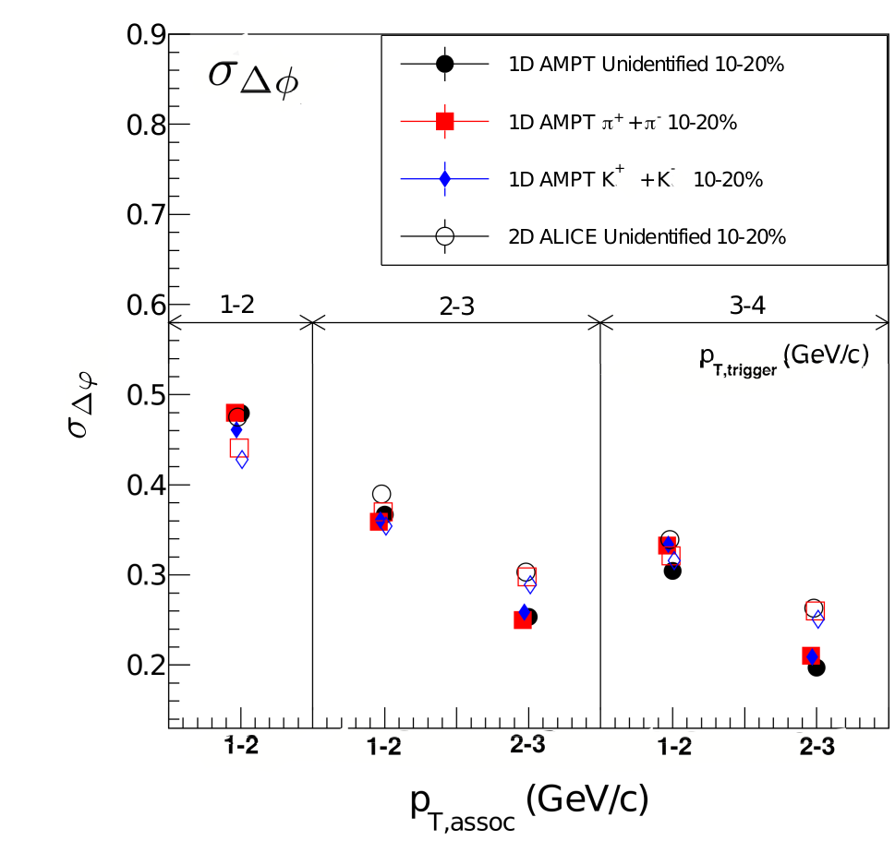 | 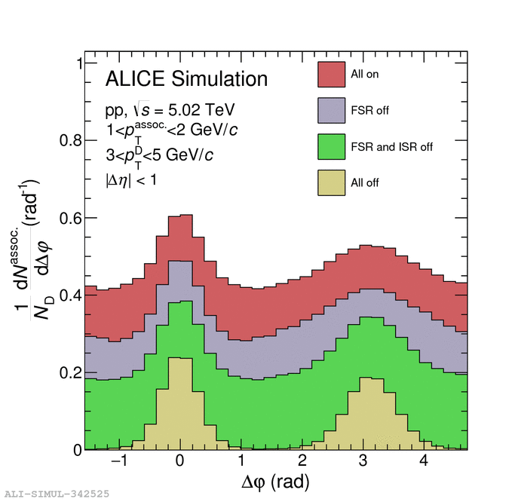
Figure 1. Left: Comparison of the of correlation peak variances in the azimuthal direction from AMPT to those from ALICE data in Pb-Pb collisions at √s_{NN} = 2.76 TeV. Right: Different parton level contributions to the D-h correlation peak in the ALICE detector, computed using PYTHIA8 simulations.
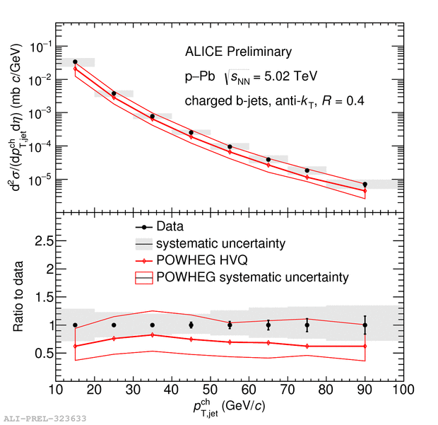 | 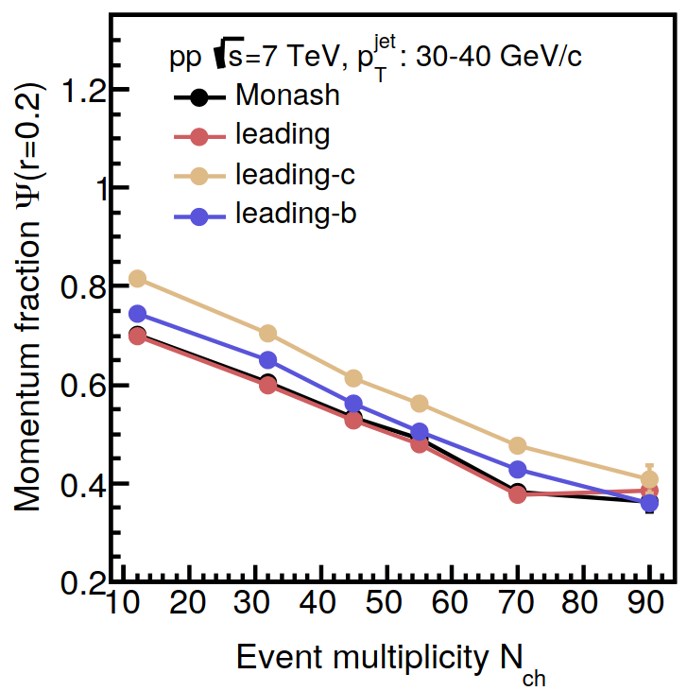
Figure 2. Left: Cross section of beauty jets in p-Pb collisions at √s_{NN}=5.02 TeV in the ALICE experiment, compared to a theory calculation. Right: Comparison of light- and heavy-flavour jet structures for different final-state multiplicites in simulations with PYTHIA8.

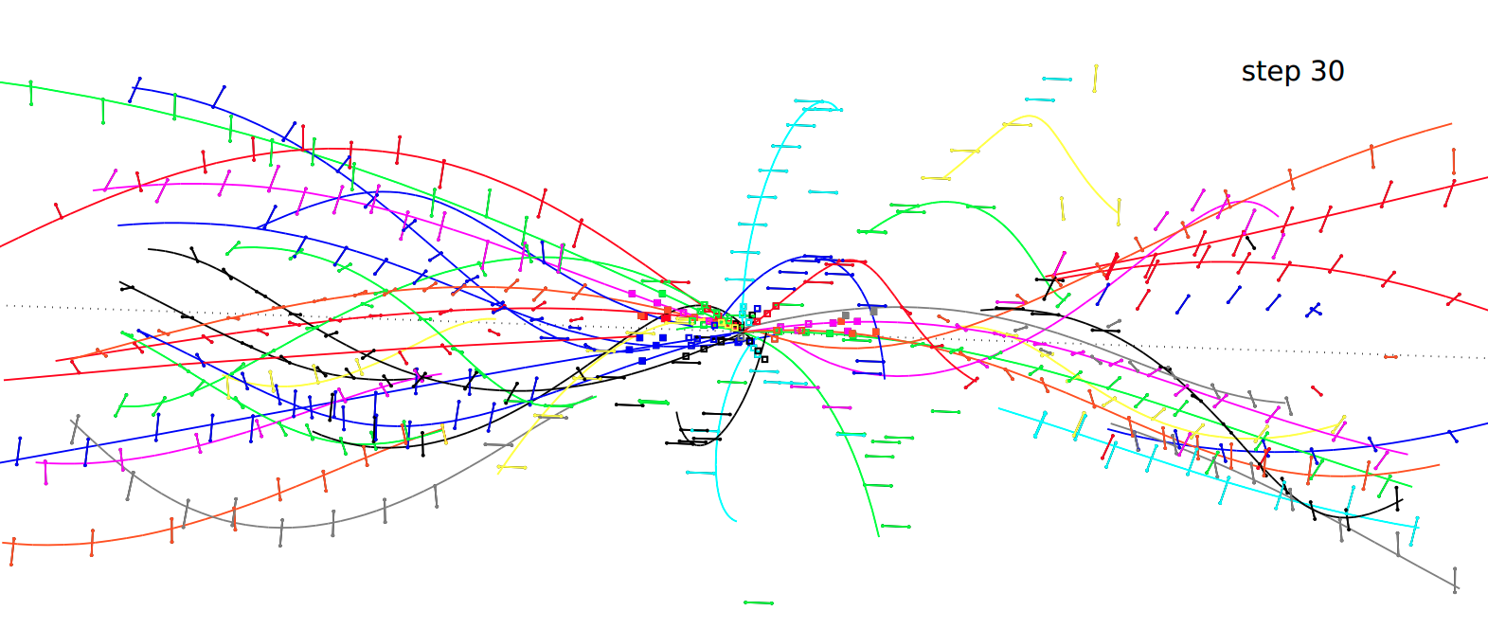
Figure 3. Hits (points and line segments) and reconstructed trajectories (colored curves), of a simulated proton-proton collision event.

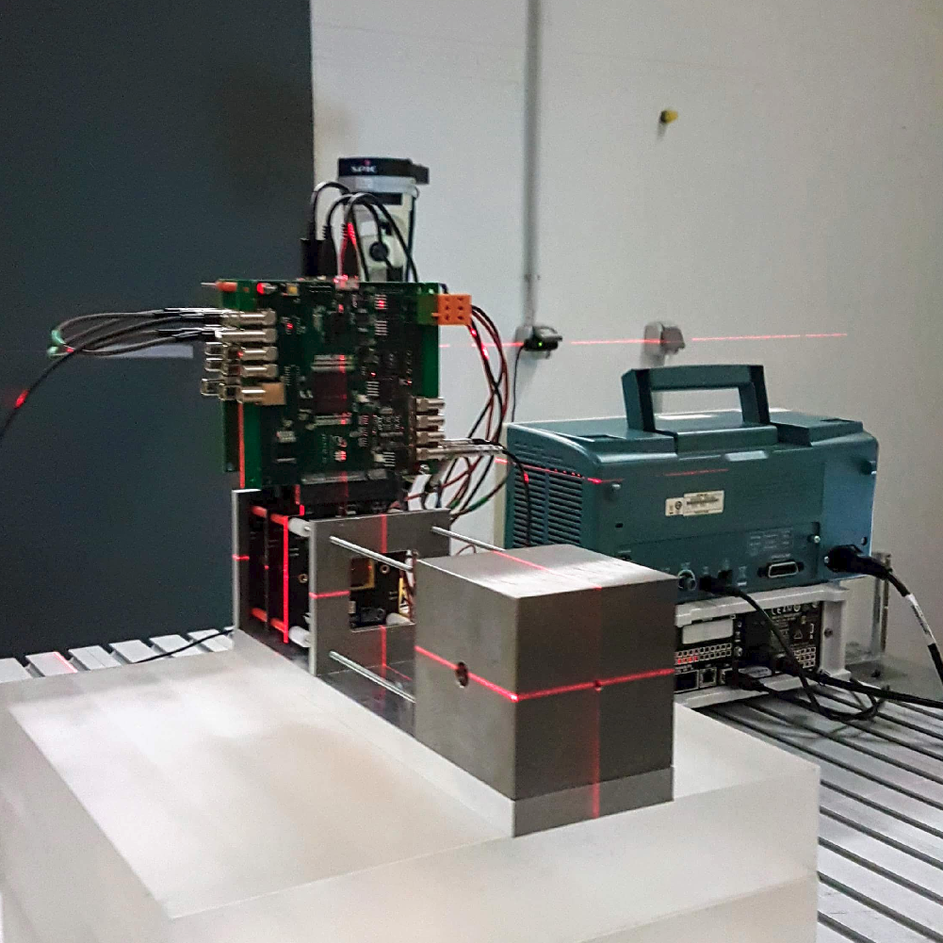 | 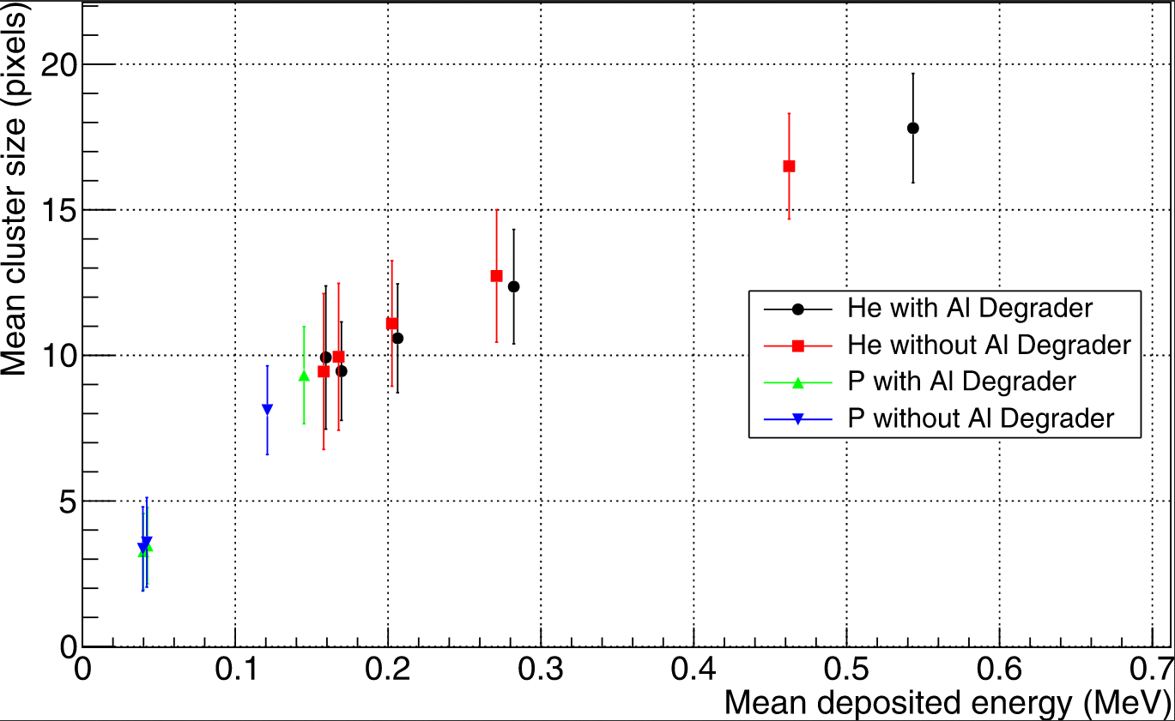
Figure 4. Left: Test beam setup for the characterization of detectors to be used as sampling calorimeter for the pCT medical application. Right: Energy dependence of the cluster size of the ALPIDE pixel detector.
Grants
NKFIH FK 131979: Investigation of collective phenomena and multiple-parton interactions in small systems created at LHC energies using light- and heavy-flavor (R Vértesi, 2019-2023).
NKFIH K 128786: Consortional assoc.: Novel tests of the strong interaction with the CERN CMS experiment (F Siklér, 2018-2022).
NKFIH K 120660: Investigation of the identified hadron production in the heavy-ion collisions at the high-luminosity LHC by the ALICE experiment (G G Barnaföldi, 2016-2020)
International cooperation
ALICE, CMS, FOPI, NA49, and NA61 (CERN); PHENIX and STAR (BNL); Bergen pCT Collaboration. Nuclear Physics Institute, Prague/Rez, Czech Republic; Universidad Autonoma de Mexico, Mexico City, Mexico; Central China Normal University, Wuhan, China.

