R-H. Hadron physics

Ferenc Siklér, Gyula Bencédi, Zoltán Fodor^{A}, Endre Futó^{A}, Sándor Hegyi, Gábor Jancsó^{A}, József Kecskeméti^{A}, Gabriella Pálla^{E}, Zoltán Seres^{A}, Mónika Varga-Kőfaragó, Róbert Vértesi

The aim of our research group is to better understand the strong interaction through collisions of nucleons and nuclei by performing basic and advanced measurements (cross sections, particle spectra and correlations), and by testing various theoretical ideas (quark-gluon plasma, gluon saturation, critical endpoint of the phase diagram). We participate in several complementary experiments (mainly ALICE and CMS), both in data-taking and physics analysis.

Quantum correlations. — We have finally published a paper on short-range two-particle correlation functions of identified hadrons in pp, p-Pb, and peripheral Pb-Pb collisions at LHC energies. The extracted radii of the particle emitting source (via Bose-Einstein correlations) are in the range 1-5 fm, reaching highest values for very high multiplicity p-Pb and Pb-Pb collisions (Fig 1, left). The dependence of the radii on the multiplicity and pair transverse momentum factorizes and appears to be less sensitive to the type of the collision system and center-of-mass energy. The observed similarities may point to a common critical hadron density reached in the collisions.

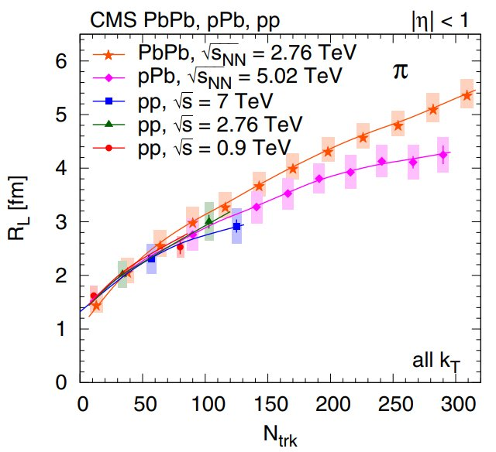 | 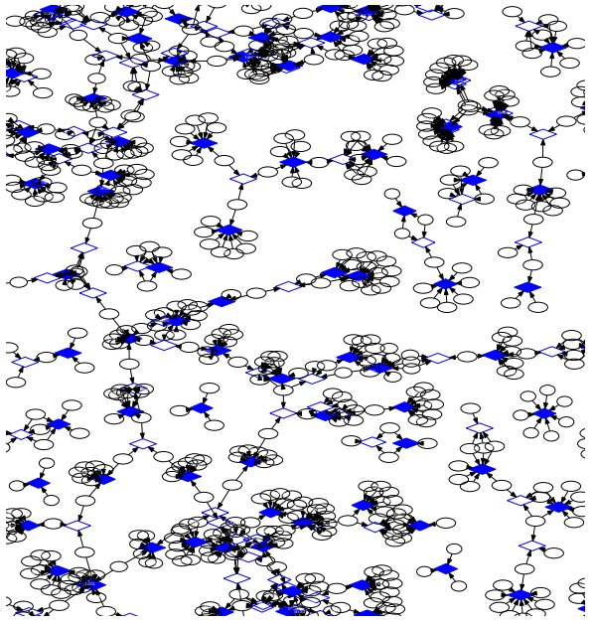
Figure 1. Left: Track-multiplicity dependence of the two-dimensional pion radius parameters obtained from fits for all collision systems studied. Lines are drawn to guide the eye.. Right: A small fraction of the bipartite graph of hits (ellipses) and track candidates (diamonds) for an event with multiple (40) pp collisions. Directed arrows, graph edges, show potential hit-to-track candidate assignments.

Novel reconstruction methods. — We have published a paper on a novel combination of established data analysis techniques for the reconstruction of all tracks of primary charged particles created in high energy collisions. Suitable track candidates are selected by transforming measured hits to a binned track parameter space. Subsequently, their number is further narrowed down by a Kalman filter-based technique. Track candidates and their corresponding hits form a highly connected network, a bipartite graph, where one allows for multiple assignments of hits to track candidates (Fig 1, right). The graph is cut into very many mini-graphs by removing a few of its components. Finally, the hits are distributed among the track candidates by exploring a deterministic decision tree. Simplified models of LHC silicon trackers are employed to study the performance of the proposed method in the case of single or many simultaneous proton-proton collisions, and for single heavy-ion collisions.
In addition, we have developed another track reconstruction method which uses of both local and global information while keeping competing choices open. The measured hits of adjacent tracking layers are clustered first with help of a mutual nearest neighbor search in angular distance. The resulted chains of connected hits are used as initial clusters for the robust k-medians clustering. This latter proceeds by alternating between the hit-to-track assignment and the track-fit update steps, until convergence. The calculation of the hit-to-track distance and that of the track-fit χ2 is performed through the global covariance of the measured hits. The clustering is complemented with elements from a more sophisticated Metropolis-Hastings MCMC algorithm, with the possibility of adding new track hypotheses or removing unnecessary ones.

Angular-correlation measurements. — We have analyzed the Pb-Pb data taken by the ALICE collaboration in 2015, and we have shown new preliminary results from it at The 27th International Conference On Ultrarelativistic Nucleus-Nucleus Collisions (QM 2018) on unidentified two-particle angular correlations in Pb-Pb and pp collisions. The presented new results exhibit a similar broadening of the jet peak towards central collisions at low transverse momentum in Pb-Pb collisions at √s_{NN} = 5.02 TeV as was seen previously at √s_{NN} = 2.76 TeV. The results were accepted for publication in Nuclear Physics A. In addition, we are working on the analysis of different Monte Carlo simulations to determine the origin of the observed phenomena. We are analyzing both unidentified and identified two-particle correlations, and the results were presented on a poster at the International Conference on Hard and Electromagnetic Probes of High-Energy Nuclear Collisions in 2018.

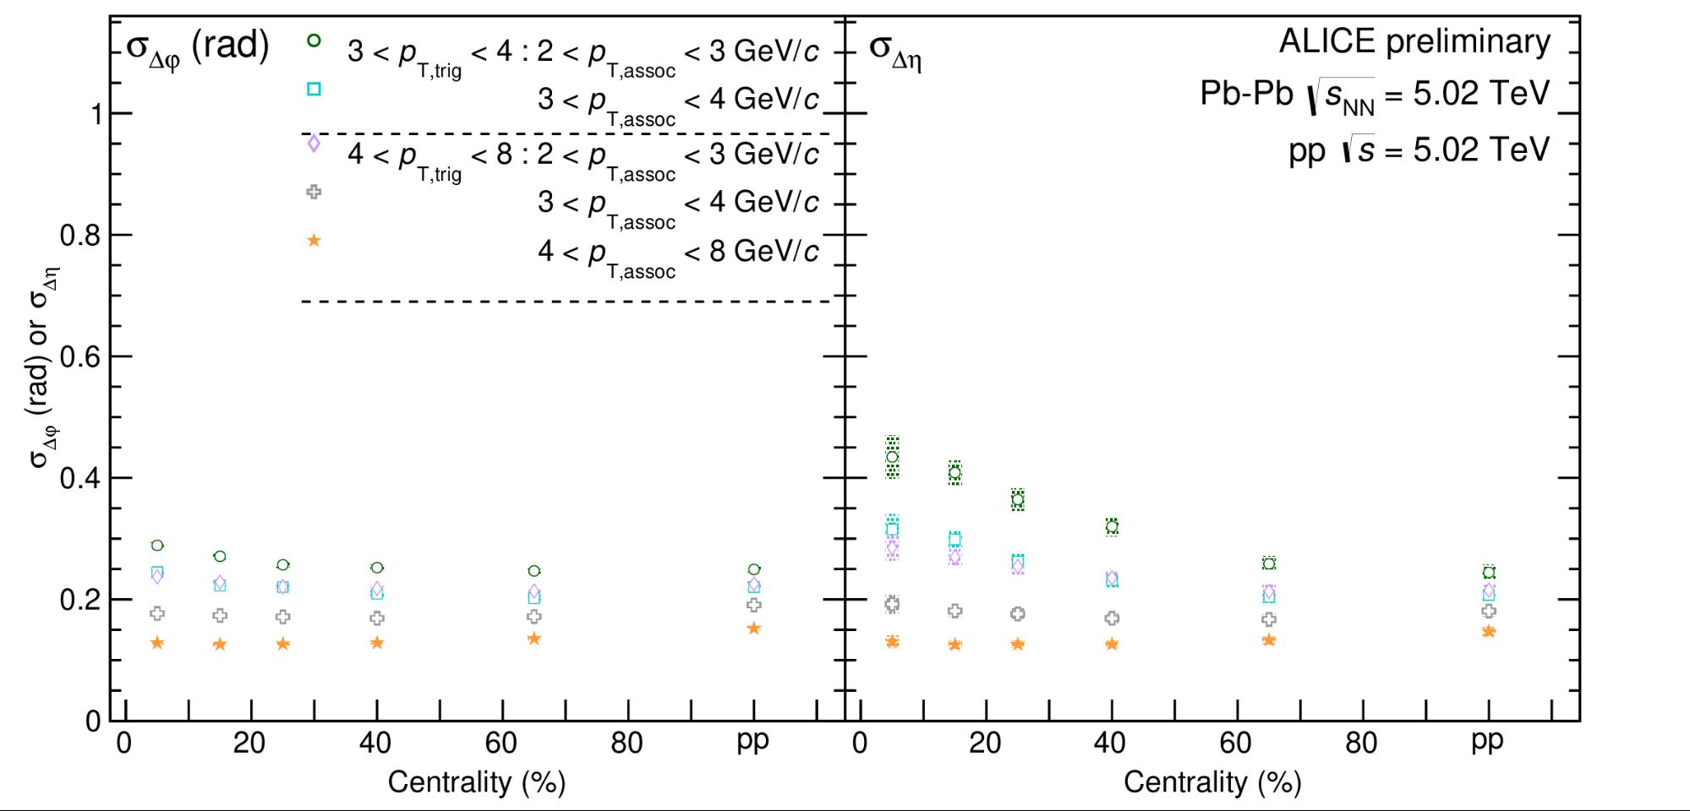 | 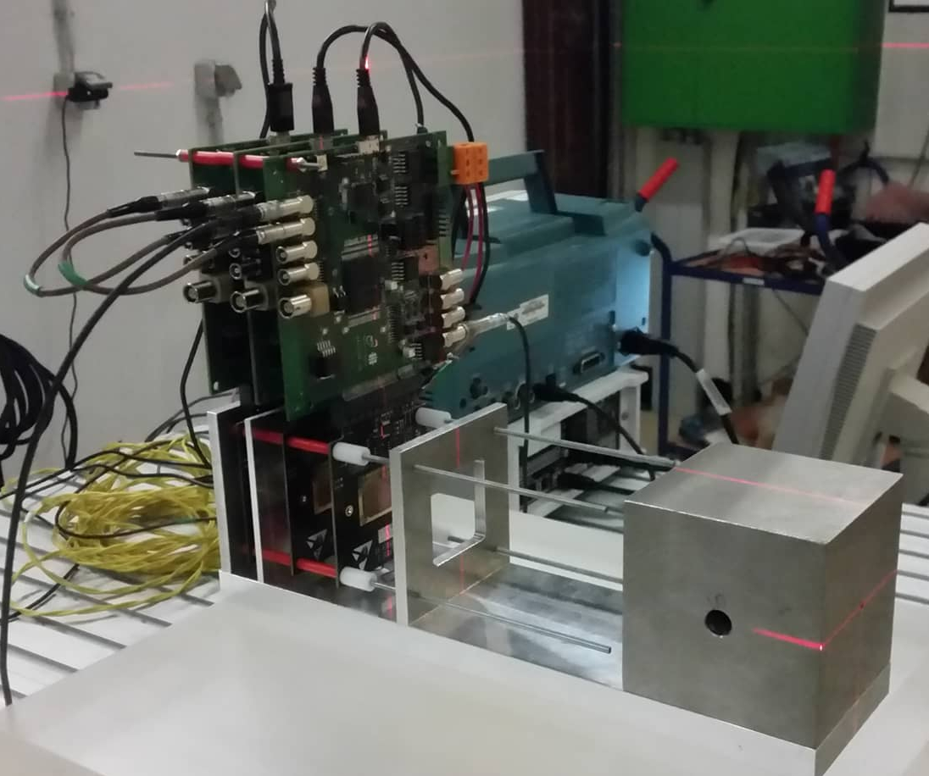
Figure 2. Left: Width of the jet peak from two-particle angular correlations in Pb-Pb collisions at √s_{NN} = 5.02 TeV as a function of centrality. The rightmost points show results from pp collisions at the same energy for comparison. Right: Test beam setup used for the characterization of detectors to be used as a sampling calorimeter for the medical application.

Medical applications of high energy detector technologies. — We have joined the development of a sampling calorimeter to be used for imaging in cancer therapy. Cancer tumors can be killed by irradiating them by photons or hadrons. In the case of the treatment by hadrons, the energy deposition and therefore the destructive effect can be focused into the tumor with changing the energy of the hadron beam. In the case of photons, however, most of the energy is deposited at the entrance of the beam. This means that in the treatment with hadrons, the patient receives less unnecessary dose and the treatment can be applied closer to critical organs. However, to reach the full potential of such a treatment the imaging of the patient has to be done by hadrons (mostly commonly protons) as well. We are developing a calorimeter based on the silicon detector developed for the upgrade of the Inner Tracking System of ALICE for such imaging purposes. Our group is taking part in the analysis of the test beam data that will determine whether the chosen detector is suitable for this lower energy regime compared to its original purpose at the LHC.

Production of (un)identified particles in pp collisions. — The transverse momentum (p_{T}) spectra of light-flavor hadrons in pp collisions measured over a broad p_{T} range provide important input for the study of particle production mechanisms in the soft and hard scattering regime of QCD. We have measured the inclusive, as well as multiplicity-dependent, charged particle transverse momentum distributions for pp collisions at different center-of-mass energies at the ALICE experiment. For pp collisions at √s = 13 TeV and for a fixed multiplicity interval, the parameters obtained from the blast wave analysis of momentum spectra are used to characterize the evolution of the spectral shapes for different event topologies. The multiplicity and spherocity dependencies of the average transverse momenta and integrated yields as a function of charged-particle multiplicity are investigated. The average p_{T} is larger (smaller) in “jetty” (isotropic) events hinting at different dynamics of particle production. The evolution of the proton-to-pion and kaon-to-pion particle ratios as a function of p_{T} suggest that the collective-like behavior can be controlled by transverse spherocity. The hadron yields scale with charged-particle multiplicity across different √s and colliding systems which indicates that hadrochemistry is dominantly driven by multiplicity. The QCD-inspired models describe several aspects of data. These results were presented at The 27th International Conference On Ultrarelativistic Nucleus-Nucleus Collisions (QM 2018).

Heavy-flavour production. — Heavy-flavour (beauty and charm) quarks are produced almost exclusively in initial hard processes, and their yields remain largely unchanged throughout a heavy-ion reaction. Nevertheless, they interact with the nuclear matter in all the stages of its evolution. Thus, heavy quarks serve as ideal self-generated penetrating probes of the strongly interacting QGP. Jets containing heavy flavour hadrons probe the influence of mass and color-charge effects on fragmentation, as well as provide insight to gluon splitting processes. The ALICE detector has the unique capability of measuring beauty-jets down to relatively low momenta. Our group plays a leading role in ALICE beauty-jet measurement in p-Pb collisions at √s_{NN} = 5.02 TeV.

Jet structures. — Collective behavior of high multiplicity events in small systems have also been observed in the heavy-flavour sector. Recent analyses of pp and p-Pb collisions show a universal enhancement of heavy-flavour particles that is usually attributed to multiple parton interactions and higher gluon radiation associated with short distance production processes. We have carried out extensive studies using the PYTHIA8 as well as the HIJING++ Monte-Carlo event generators. We have given predictions for multiplicity-dependent jet structures, and proposed a way to validate the presence and extent of effects such as multiple-parton interactions or color reconnection. We have demonstrated that vacuum QCD effects can modify the jet structure, as well as two-particle angular correlation pictures, in high-multiplicity events. We also gave predictions to flavour-dependence of jet shape modification vs. momentum and multiplicity. We have also introduced a definition of a characteristic jet size measure that is independent of multiplicity. We started the experimental analysis of jet shapes in ALICE Run-2 data in cooperation with the CCNU ALICE group in order to verify or exclude the presence of jet-modification by vacuum-QCD effects.

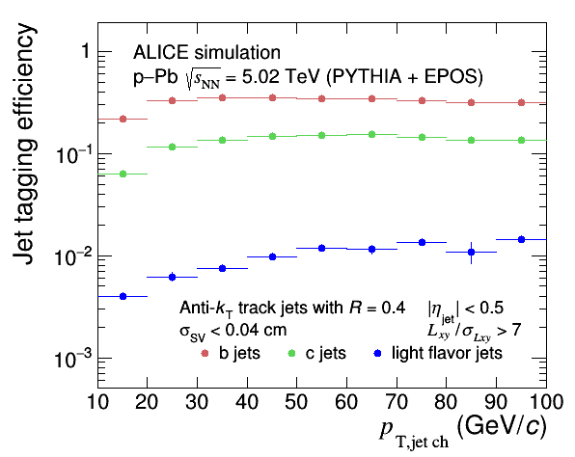 | 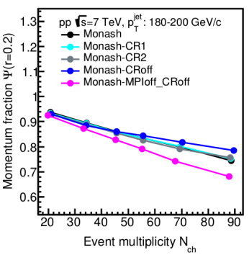
Figure 3. Left: Tagging efficiencies of beauty, charm and light flavour jets in p-Pb collisions at √s_{NN}=5.02 TeV in the ALICE experiment. Right: Modification of the jet structures by multiple-parton interactions and different color reconnection schemes in simulations with PYTHIA8.

Grants
NKFIH K 128786: Consortional assoc.: Novel tests of the strong interaction with the CERN CMS experiment (F Siklér, 2018-2022)
NKFIH K 120660: Investigation of the identified hadron production in the heavy-ion collisions at the high-luminosity LHC by the ALICE experiment (GG Barnaföldi, 2016-2020)

International cooperation
ALICE, CMS, FOPI, NA49, and NA61 (CERN), PHENIX and STAR (RHIC)

