Hadron Physics Research Group
Wigner Research Group
Róbert Vértesi, Gyula Bencédi, Zoltán Fodor^{A}, Endre Futó^{A}, Sándor Hegyi, Gábor Jancsó^{A}, József Kecskeméti^{A}, Aditya Nath Mishra, Gabriella Pálla^{E}, Zoltán Seres^{A}, Ferenc Siklér, Mónika Varga-Kőfaragó^{B}, Zoltán Varga, Sándor Hegyi.
^{A} External member
^{B} On leave
^{E} Professor Emerita
Students and junior researchers: László Gyulai, Eszter Frajna, Anett Misák, Attila Rádl, Ákos Sudár, Szende Sándor, Olivér Surányi, Balázs Endre Szigeti.

High-momentum hadron production in the ALICE experiment. — Light-flavor particle spectra are the benchmark test for perturbative QCD calculations beyond leading order, as well as for fragmentation models (Fig. 1). They also provide the baseline for potential nuclear modification in larger collision systems as well as small systems with high final-state multiplicities. The production of light-flavor mesons and baryons was measured in inelastic proton-proton (pp) collisions at a center-of-mass energy of √s=7 TeV and √s=13 TeV at midrapidity as a function of transverse momentum, using the ALICE detector at the CERN LHC. A hardening of the spectra at high p_{T} with increasing collision energy was observed. Our group played a leading role in these measurements [1]. This work is being continued with differential data analysis in ALICE pp and pPb collisions, by characterizing the underlying event region as a function of the transverse event activity classifier.
Central exclusive production with the CMS experiment. — We published a paper on the central exclusive and semi-exclusive production of π⁺π⁻ pairs measured with the CMS detector in pp collisions at center-of-mass energies of √s=5.02 and 13 TeV [2]. The theoretical description of these nonperturbative processes, which have not yet been measured in detail at the LHC, poses a significant challenge to models. The two pions are measured and identified in the CMS silicon tracker based on specific energy loss, whereas the absence of other particles is ensured by calorimeter information. The total and differential cross sections of exclusive and semi-exclusive central π⁺π⁻ production are measured as functions of invariant mass, transverse momentum, and rapidity of the π⁺π⁻ system in the fiducial region defined as transverse momentum p_{T,π} > 0.2 GeV and pseudorapidity |η_{π}|<2.4 (Fig. 2). The production cross sections for the four resonant channels f₀(500), ρ⁰(770), f₀(980), and f₂(1270) are extracted using a simple model. These results represent the first measurement of this process at the LHC collision energies of 5.02 and 13 TeV [3].
We have completed the analysis of a large amount of high-quality pp collision data taken in 2018, at √s=13 TeV centre-of-mass energy. Our aim was to study and understand exclusive production, trying to uncover the spin-structure of the pomeron. Events are selected by requiring scattered protons detected in the very forward roman pot detectors, exactly two centrally produced oppositely charged particles identified in the silicon tracker, and a momentum balance of the four particles. A fully differential, detailed partial wave (spin-parity) analysis of the angular distributions of the decay daughters reveals several f₀ and f₂ resonances. Their helicity amplitudes as functions of invariants are precisely measured and compared to vector- and tensor-pomeron models. We have measured the effective meson-pomeron form factors, an essential input for theoretical models. The mass pole and couplings of the f₀(980) are measured, along with branching ratios of scalar and tensor resonances. The analysis of the four-hadron final state is promising, where we collaborate with other groups with the final goal to elucidate the case for some potential glueball candidates near 2 GeV mass. We are in the process of writing an initial paper on the nonresonant continuum and preparing another on resonance production.
Beauty-jet production in small systems with the ALICE experiment. — The production of heavy-flavor jets in proton-proton collisions serves as a fundamental test of perturbative QCD, while p-Pb (Pb-Pb) measurements provide information about the effects of the cold (and hot) nuclear matter. Our group plays a key role in several experimental measurements within the ALICE Heavy Flavor Jets and Correlations physics analysis group [4]. One such analysis is the measurement of the b-jet production at √s=5 TeV in pp and p-Pb collisions. Preliminary results on the production spectra in both systems, as well as the nuclear modification factor in p-Pb collisions, have already been made public [5]. With the excellent particle tracking capabilities of ALICE detector, these results extend to unprecedentedly low momenta (10 GeV/c) and pave the way to the understanding of flavor-dependent jet fragmentation as well as nuclear modification. Finalization of the results is currently underway.
Correlation of D mesons with charged hadrons. — Correlation measurements of D mesons with charged hadrons reveal the heavy-flavor jet structure at intermediate momenta. Simulations on D-h correlations in pp collisions at √s=5 TeV, aimed at the detailed understanding of partonic and hadronic contributions to heavy-flavor jet production were evaluated [5]. Our group is also a main contributor to the D-h correlation measurements in pp collisions at √s=13 TeV by the ALICE experiment [6], and to the preparation of the corresponding publication. Furthermore, we participate in the peak shape analysis of heavy-flavor electron to hadron correlations in √s=5 TeV pp and p-Pb collisions. This work will become part of a later ALICE publication.
Investigating the underlying event with identified leading processes. — The event-activity differential investigation of particle production reveals the connection between the leading process and the underlying event. It allows for the study of semi-soft vacuum-QCD effects potentially responsible for collectivity in events with higher activity, such as multiple-parton interactions (MPI). Flavor-dependent studies of these mechanisms can help separate color-charge and mass effects in jet production and fragmentation [7]. We conduct an ALICE measurement of the transverse event-activity dependent D⁰ meson production.
We investigate the connection of flavor-dependent hard hadroproduction to the underlying event in a phenomenological study together with the colleagues at UNAM, using Monte Carlo simulations. A characteristic enhancement of MPI was found at intermediate momenta, that could be identified as gluon-initiated triggers. We also demonstrated that beauty triggers can be used as proxies for quark-initiated processes [8]. We used simulations to interpret heavy-flavor production in the jet and the underlying event region in case of unidentified as well as identified jet triggers, and proposed a method that establishes the connection of higher-order heavy-flavor production to MPI activity [9].
Scaling properties of jet structures. — A. Gémes contributed to the research of the group during his summer practice, with advisor R. Vértesi and external expert G. G. Barnaföldi. We studied the structure of jets in proton-proton collisions at LHC energies using Monte Carlo simulations. We demonstrate that the radial jet profiles exhibit scaling properties with charged-hadron event multiplicity over a broad transverse-momentum range (Fig. 3). We also provided parametrizations of the jet profiles based on different statistically-motivated analytical distributions. Based on this we proposed that the scaling behavior stems from fundamental statistical properties of jet fragmentation [10]. We also observed that the charged-hadron multiplicity distributions scale with jet momentum. This suggests that the Koba–Nielsen–Olesen (KNO) scaling holds within a jet. The in-jet scaling is fulfilled without MPI, but breaks down in case MPI is present without color reconnection. Our findings imply that KNO scaling is violated by parton shower or multiple-parton interactions in higher-energy collisions [11]. We also contributed to the jet structure studies in ALICE data jointly with the ALICE CCNU group.
Jet substructure measurements with the CMS experiment. — The internal substructure of jets reveals the mechanisms of the parton fragmentation processes. We have compared different model predictions to proton-proton collision data recorded by the CMS experiment. We investigated clusters with high rapidity along the jet axis, and found that the basic properties of these clusters are sensitive to the applied fragmentation models.
Sudden increase in the degrees of freedom in dense QCD matter. — One of the main challenges in high energy heavy-ion collisions is to simultaneously determine the temperature and the energy density of the matter produced in a collision, and hence the number of thermodynamic degrees of freedom (DOF). We presented the extraction of the temperature by analyzing the charged particle transverse momentum spectra in lead-lead and proton-proton collisions at LHC energies from the ALICE Collaboration using the Color String Percolation Model (CSPM). From the measured energy density (ε) and the temperature (T) the dimensionless quantity ε/T⁴ is obtained to get the degrees of freedom (DOF), ε/T⁴ = DOF²/30. We observe for the first time a two-step behavior in the increase of DOF, characteristic of deconfinement, above the hadronization temperature, at a temperature ~210 MeV for both Pb-Pb and pp collisions, and a sudden increase of the DOF to the ideal gas value of ~47 corresponding to three quark flavors in the case of Pb-Pb collisions [12].
Study the quark-gluon plasma using correlations of identified light hadrons. — The interaction of intermediate-momentum particles with the hot and dense, strongly interacting matter created in nucleus-nucleus collisions is possible using correlations of light-flavor hadrons. We have analyzed Pb-Pb collisions at √s_{NN}=5.02 TeV data taken by the ALICE collaboration in 2018. The unidentified angular correlation results shows a similar broadening of the jet peak towards central collisions at low transverse momentum in Pb-Pb collisions at √s_{NN}=5.02 TeV to that already observed at √s_{NN}=2.76 TeV. The identified angular correlation results exhibit a clear particle species dependence. In addition, we are working on the analysis of different Monte Carlo simulations to determine the origin of the observed phenomena [13].
Medical applications of high energy detector technologies. — We participate in the Bergen pCT collaboration, formed for the development of a sampling calorimeter to be used for imaging in cancer therapy. Irradiation of cancer tumors using well-focused hadron (most commonly proton) beams can be a very effective treatment as the patient receives less unnecessary dose, thus allowing for a deposit of high destructive dose close to the critical organs. The ALPIDE calorimeter (Fig. 4) is based on the silicon pixel detector developed for the upgrade of the Inner Tracking System of ALICE. We have estimated the performance of the detector design using Monte Carlo simulations [14]. The ALPIDE detectors are already being produced and tested, and the group is currently working on the last refinements of the electronics and mechanics. In parallel, we are in the development of a data and image reconstruction algorithm partially based on machine learning techniques [15]. We expect the first real test results in the near future.

References:
[1] ALICE Collaboration, (Bencédi Gy), accepted in EPJC, arXiv:2005.11120 (2020)
[2] CMS Collaboration, Eur. Phys. J. C 80 (2020) 718
[3] Surányi O (CMS), PoS ICHEP2020, 508 (2020)
[4] Vértesi R (ALICE), PoS LHCP2020, 143 (2020)
[5] Frajna E, Vértesi R, Fizikai Szemle 70, 7-8 (2020) 249
[6] Frajna E (Advisor: Vértesi R), MSc thesis, BME (2020)
[7] Gyulai L (ALICE), J. Phys.: Conf. Ser. 1690 (2020) 012165
[8] Misák A (Advisor: Vértesi R), BSc thesis, BME (2019)
[9] Sándor Sz (Advisor: Vértesi R), TDK thesis, ELTE (2020)
[10] Gémes A, Vértesi R, Barnaföldi G G, Papp G, World Scientific: Gribov-90 Memorial Volume, arXiv:2008.08500 (2020)
[11] Vértesi R, Gémes A, Barnaföldi G G, arXiv:2012.01132 (2020)
[12] Mishra A N, arXiv:2006.10169 (2020)
[13] Szigeti B E (Advisors: Varga-Kőfaragó M, Nagy M), PhD thesis, ELTE (2020)
[14] Bergen pCT Collaboration, Frontiers in Physics 8 (2020) 460
[15] Bergen pCT Collaboration, Nucl. Instrum. Methods Phys. Res. A 958 (2020) 162626

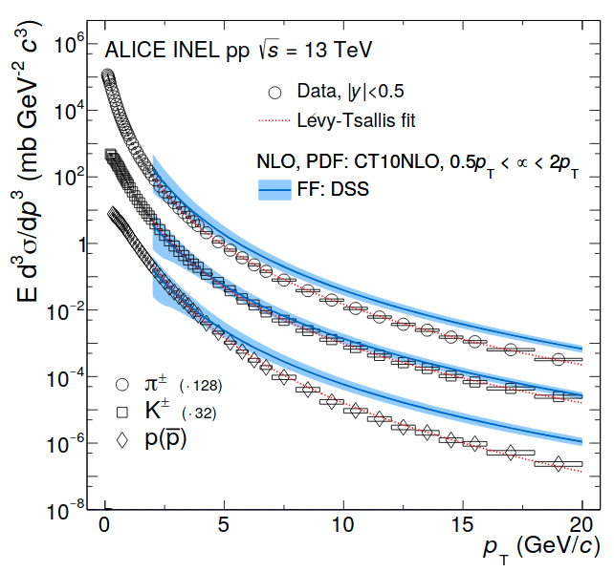  Figure 1. Invariant differential cross sections for π±, K±, and p(anti-p) production in pp collisions at √s=13 TeV with the ALICE experiment, compared to pQCD model calculations and a phenomenological fit. | 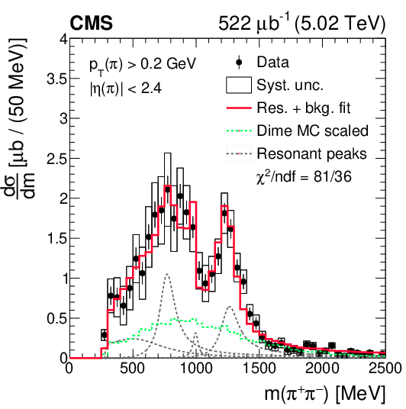  Figure 2. Central exclusive π⁺π⁻ production cross sections with the CMS experiment in pp collisions at √s=5.02 TeV, and a model fit that accounts for resonances as well as the continuum.
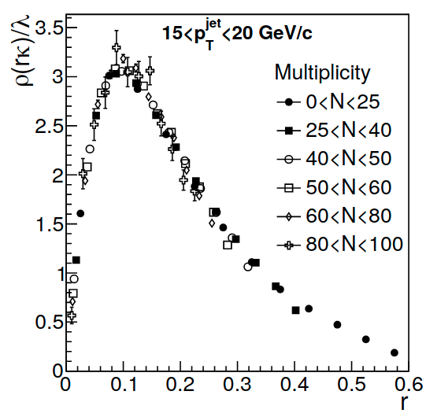  Figure 3. Jet-momentum profiles after background subtraction, in different event-multiplicity classes in simulated pp collisions at √s=7 TeV, after the application of the scaling function. | 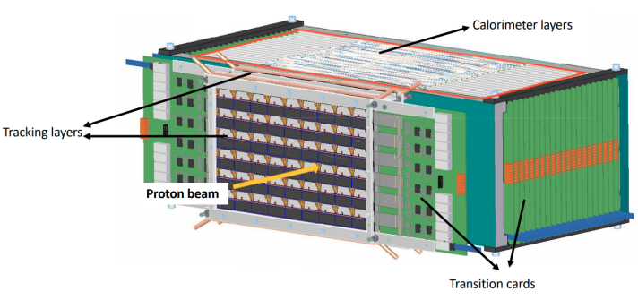  Figure 4. Visualization of the Bergen pCT detector without the support structure.

